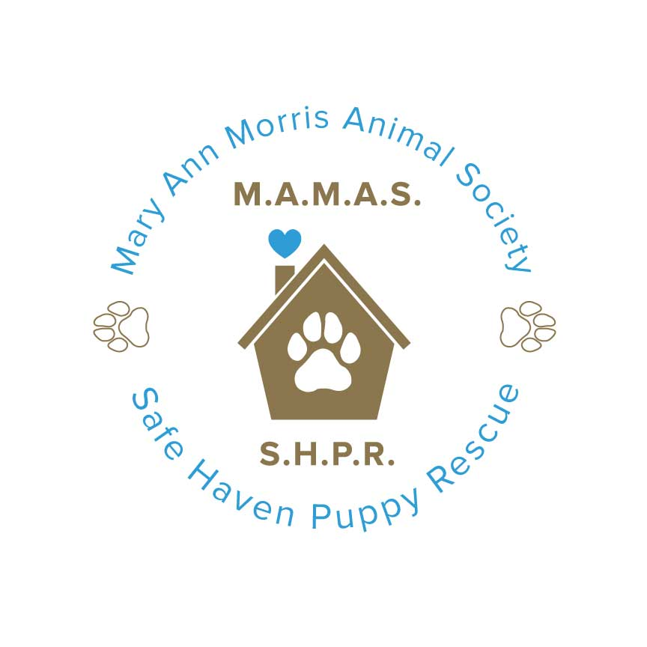

8 Tips to Prevent Parvovirus in Your Dog or Puppy
From The Animal Foundation (https://animalfoundation.com/8-tips-to-prevent-parvovirus-in-your-dog-or-puppy/)

Canine parvovirus (commonly called parvo) is a highly contagious viral disease that can produce a life-threatening illness in puppies and dogs. It can be transmitted by any person, animal or object that comes in contact with an infected dog’s feces.

Puppies, adolescent dogs, and adult dogs who are not vaccinated are at risk of contracting the virus. Protecting your puppy or dog from parvovirus could save his life.

Keep your dog healthy and parvo-free with these 8 tips:
- Make sure your dog is properly vaccinated. Puppies should receive their first vaccines at 6-8 weeks of age; boosters should be administered at three-week intervals until the puppy is 16 weeks of age, and then again at one year of age. Previously vaccinated adult dogs need boosters every year.
- Limit your puppy or unvaccinated dog’s exposure to other dogs until he’s had his first two vaccinations, unless you are sure the other dogs are fully vaccinated.
- Avoid places where your puppy or unvaccinated dog could be exposed to parvovirus from unvaccinated dogs. Dog parks, pet stores, play groups, and other public areas should be avoided until your dog or puppy is fully vaccinated.
- When visiting your vet for wellness check-ups and vaccinations, carry your puppy in your arms outside and leave him on your lap while waiting in the lobby. Walking where other dogs have walked and gone to the bathroom will increase your puppy’s risk of contracting disease.
- Parvovirus is very difficult to kill and can live in the environment for over a year. If you suspect your house or yard has been infected, clean with a 1:32 dilution of bleach (1/2 cup bleach in a gallon of water). Regular soaps and disinfectants DO NOT kill parvovirus. Areas that cannot be cleaned with bleach may remain contaminated. Remember, the virus can survive on a variety of objects, including food bowls, shoes, clothes, carpet and floors.
- If you work or spend time in places where you have contact with dogs, change your clothes and shoes before returning home to your dog or puppy.
- If your dog or puppy is vomiting, has diarrhea, is not eating or is lethargic, you should take him to the vet as soon as possible. These are all symptoms of parvovirus. Remember, Infected dogs may show only one symptom!
- If you are considering adopting a new dog, we encourage leaving your unvaccinated puppies or dogs at home. It is very important to do a meet and greet, but take the time to make sure your dog is fully vaccinated first!

For more information on canine parvovirus, visit the American Veterinary Medical Association or the ASPCA online. And don’t forget to regularly vaccinate your dog!

